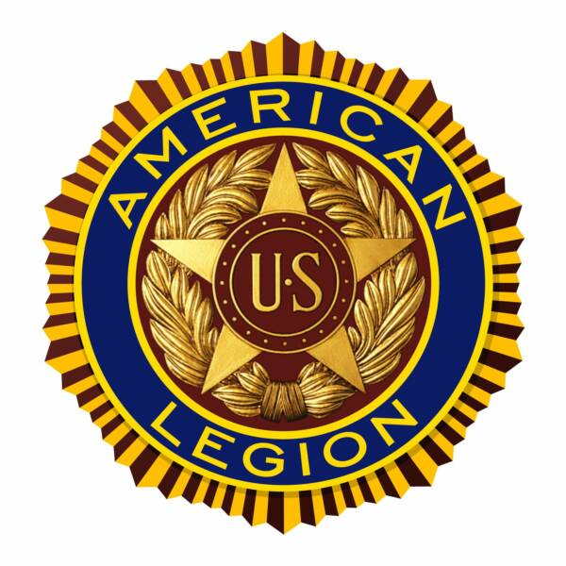**2018 Annual**

**Gretna American Legion**

**Leonard Conley Post 216**

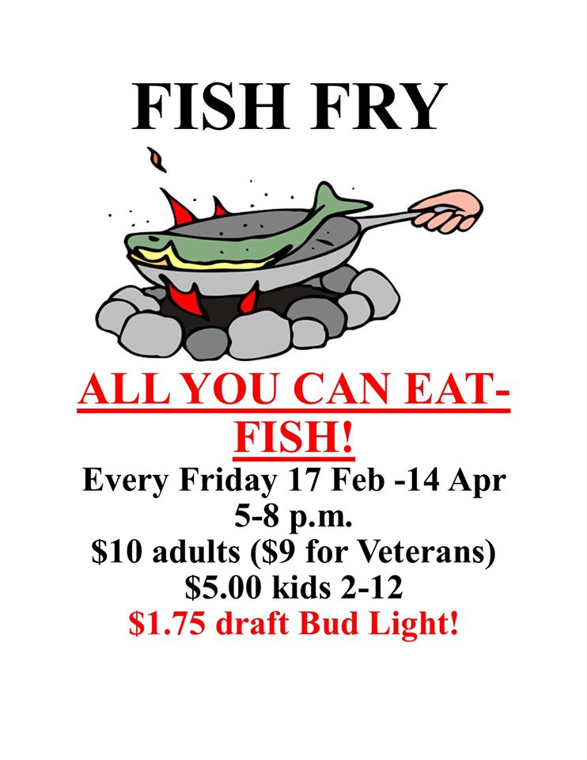

**ALL YOU CAN EAT!**

**Every Friday 16 February – 30 March**

**5-8 pm**

**$10 adults ($9 for Veterans)**

**$5.00 kids 2-12**

**$1.75 12 oz Bud Light draft!**

**Gretna American Legion**

**11690 S. 216th Street, Gretna, NE 68028**